TOUCANS | JAGUARS | CAPYBARAS | MACAWS | TAMARINS
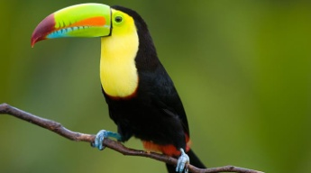  Ella  Sam  Abigail  Jacob  Sophia  Freddie | 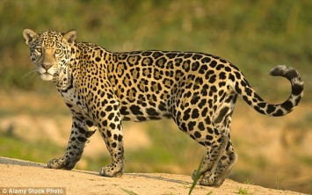  Tjay  Maddy  Betsy  Bella  George  Alfie R  Josh W | 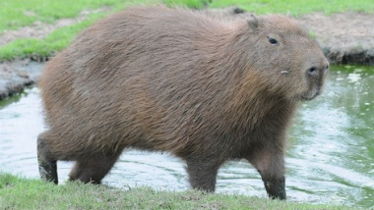  Mia  Chloe  Sonny  Sophia  Ben P  Ben S | 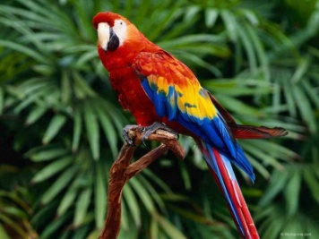  Stanley  Nicole  Carla  Alfie M  Ellie  Adam | 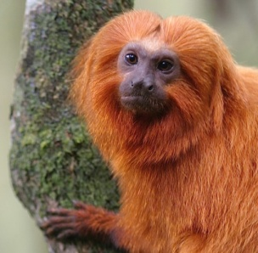  Grace  Josh C  Josh H  Ella-Rose  Rose  Theo

